UNIT-III

OPERATIONS ON AN AVL TREES
The basic operations performed on an AVL tree are
- Searching an element
- Inserting a new element
- Deleting an element

INSERTION OPERATION ON AVL TREES
In AVL Tree, new node is always inserted as a leaf node. The insertion operation is performed as follows....
Step 1: Insert the new element into the tree using Binary Search Tree insertion logic.
Step 2: After insertion, check the Balance Factor of every node.
Step 3: If the Balance Factor of every node is 0 or 1 or -1 then go for next operation.
Step 4: If after insertion the balance factor of any of the nodes turns out to be anything other than 0, +1 or -1, then the tree is said to be unbalanced.

CONSTRUCTION OF AN AVL TREE
Construct AVL tree for the list by successive insertion: 5, 6, 8, 3, 2, 4, 7
i Insert 5 into empty tree
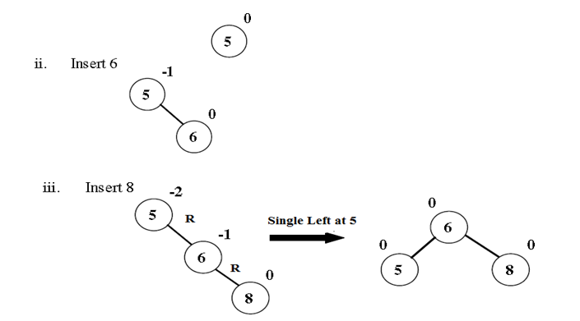

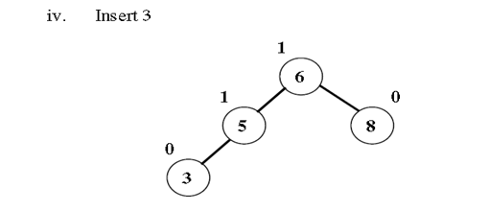

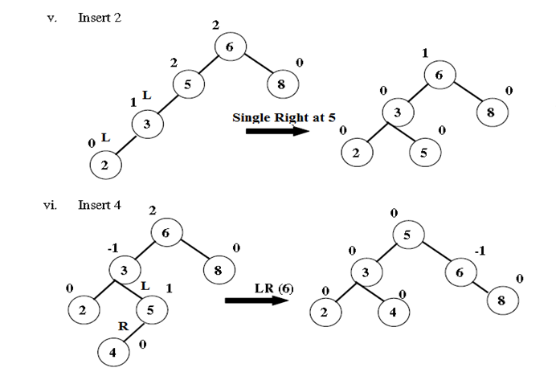

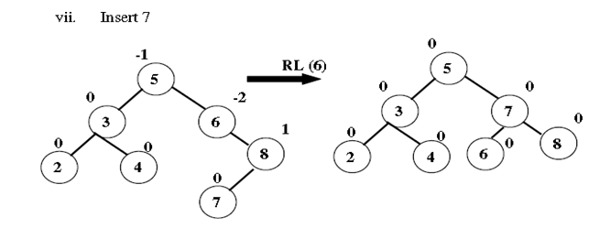

DELETION OPERATION ON AVL TREES
The sequence of steps to be followed in deletion are
- Initially, the AVL tree is searched to find the node to be deleted
- If the search is successful, delete the node. The following are the 3 possibilities for the node ‘x’ that is to be deleted
- x is a leaf – In this case the leaf node is discarded
- x has exactly one non empty sub tree – If x has no parent, the root of its sub tree becomes the new search tree root. If x has a parent P, then we change the pointer from parent p so that it points to x’s only child
- x has two non empty sub trees – x is replaced with either the largest element in the left sub tree or the smallest element in its right sub tree.
- After deletion of node, check the balance factor of each node
- Rebalance the tree if the tree is unbalanced. For this AVL tree deletion rotations are used.
- On deletion of a node x from the AVL tree. Let A be the closest ancestor node on the path from x to the root node, with a balance factor of +2 or -2. To restores balance at node A, we classify the type of imbalance as follows:

L – type imbalance:
- The imbalance is of type L if the deletion took place from A’s left sub tree.
- The balance factor of A = -2
- A has a right sub tree with root B
- L-type imbalance is sub classified into types L0, L1 and L-1 depending on the balance factor of B.

- L0 ROTATION
L0 imbalance occurs if the deletion takes place from the left sub tree of A and balance factor of B is 0
L0 rotation is Single Left rotation, that is applied at node A
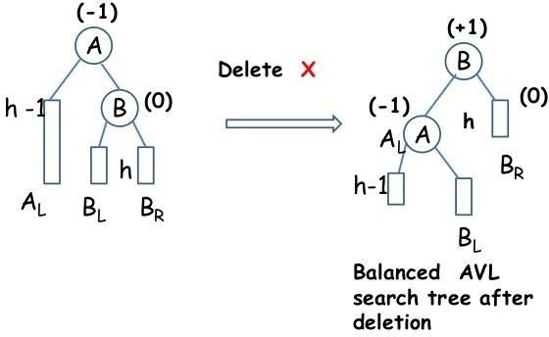
General Notation:

Example
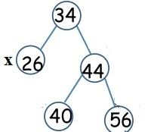
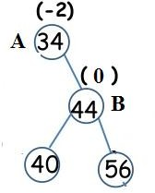
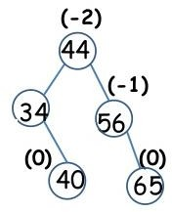
Before deletion After deleting 26 After L0 rotation

- L1 ROTATION
- L1 imbalance occurs if the deletion takes place from the left sub tree of A and balance factor of B is 1
- L1 rotation is RL rotation, which involves 2 rotations:
- Single Right
- Single Left

General Notation:
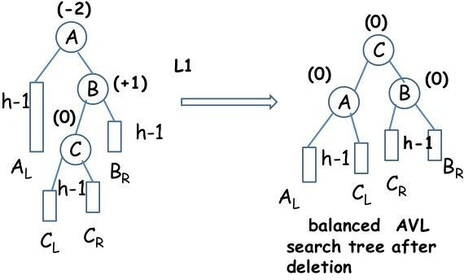

Example:
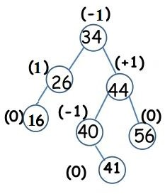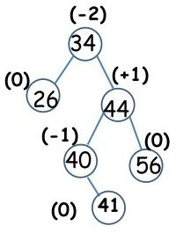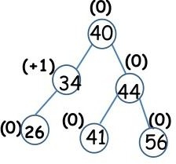
Before deletion After deleting 16 After L1 rotation

- L-1 ROTATION
- L-1 imbalance occurs if the deletion takes place from the left sub tree of A and balance factor of B is -1
- L-1 rotation is Single Left rotation, that is applied at node A

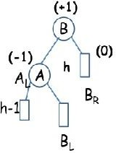
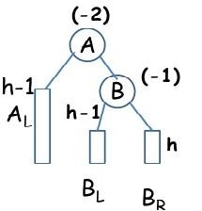
General Notation:

Example:
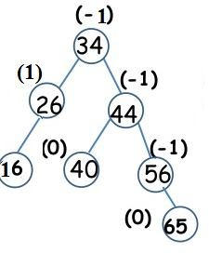
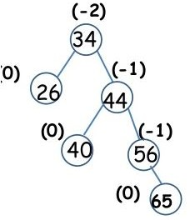
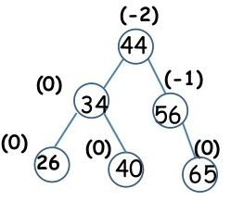
Before deletion After deleting 16 After L-1 rotation

R – type Imbalance:
    - The imbalance is of type R if the deletion took place from A’s Right sub tree.
    - The balance factor of A = 2
    - A has a left sub tree with root B
    - R-type imbalance is sub classified into types R0, R1 and R-1 depending on the balance factor of B

R0 ROTATION
  - R0 imbalance occurs if the deletion takes place from the Right sub tree of A and balance factor of B is 0
  - R0 rotation is Single Right rotation, that is applied at node A
General Notation:
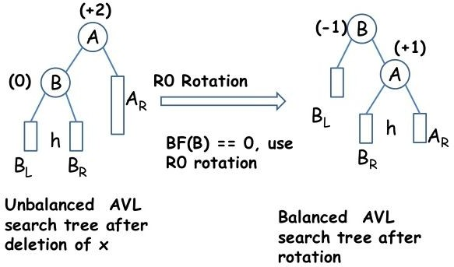
Example:
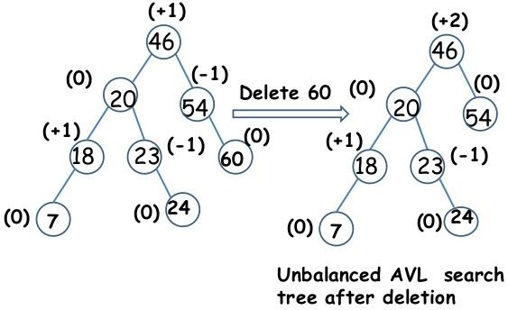
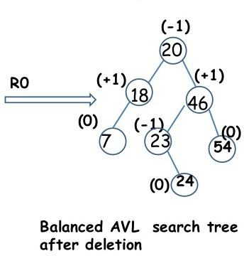

- R1 ROTATION
- R1 imbalance occurs if the deletion takes place from the Right sub tree of A and balance factor of B is 1
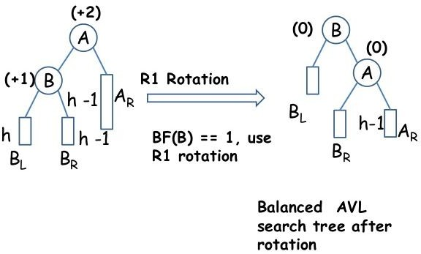
- R1 rotation is Single Right rotation, that is applied at node A
General Notation:

Example:
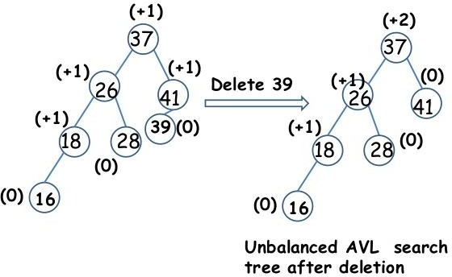
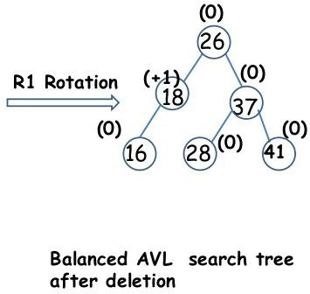

- R-1 ROTATION
- R-1 imbalance occurs if the deletion takes place from the Right sub tree of A and balance factor of B is -1
- R-1 rotation is LR rotation, which involves 2 rotations:
- Single Left
- Single Right

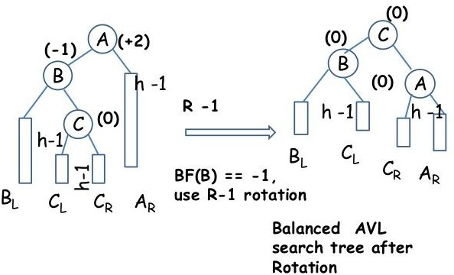
General Notation:

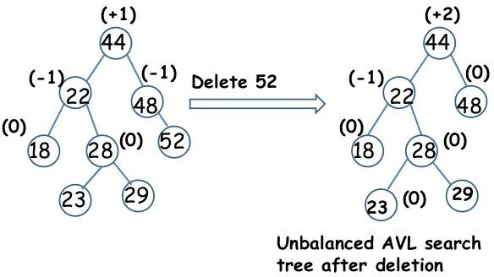
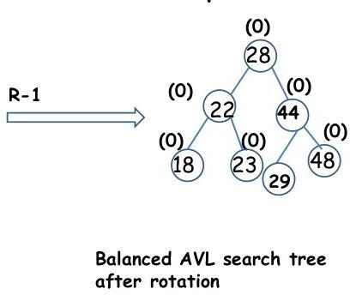
Example:

Search Operation in AVL Tree
In an AVL tree, the search operation is performed with O(log n) time complexity. The search operation in the AVL tree is similar to the search operation in a Binary search tree. We use the following steps to search an element in AVL tree...
Step 1 - Read the search element from the user.
Step 2 - Compare the search element with the value of root node in the tree.
Step 3 - If both are matched, then display "Given node is found!!!" and terminate the function
Step 4 - If both are not matched, then check whether search element is smaller or larger than that node value.
Step 5 - If search element is smaller, then continue the search process in left subtree.
Step 6 - If search element is larger, then continue the search process in right subtree.

Step 7 - Repeat the same until we find the exact element or until the search element is compared with the leaf node.
Step 8 - If we reach to the node having the value equal to the search value, then display "Element is found" and terminate the function.
Step 9 - If we reach to the leaf node and if it is also not matched with the search element, then display "Element is not found" and terminate the function.

